Intermediate Algebra Lecture C.1: A BRIEF Review of Solving Equations and Factoring
Steps:
- Simplify both sides of equation
  - Distribute
  - Combine like terms
- Eliminate smaller variable (this makes equation positive)
- Solve for the variable

Example
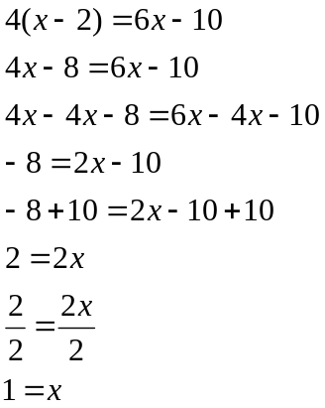

Example
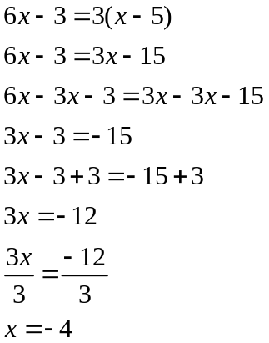

Example
Find the lowest common denominator(LCD) for handling fractions in equations
When an equation has fractions multiply both sides by the LCD
Use the largest denominator to find the LCD
Does 6 divide evenly into 16 (8 times 2)? No
Does 6 divide evenly into 24 (8 times 3)? Yes

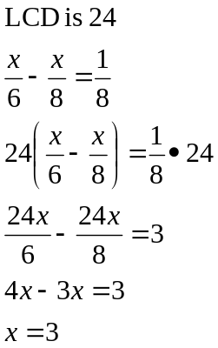

Example
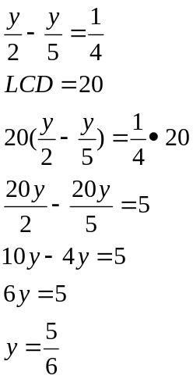
FACTORING
- Factor out the Greatest common factor first (if one exists)
- For two terms
  - Is it a difference of squares? 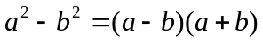
  - Is it a difference of Cubes? 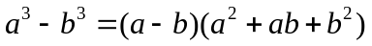
  - Is it a sum of cubes? 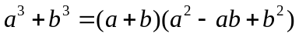

- For three terms
  - Diamond method

- For four terms
  - Factor by grouping

- Check to see if factors can be factor

Example
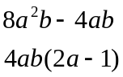

Example
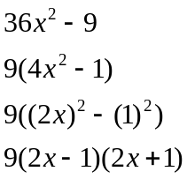

Example
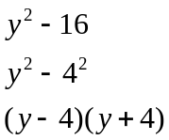

Example
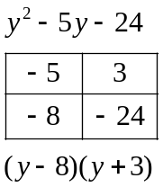

Example
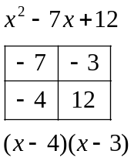

Example
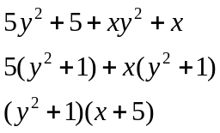

Example
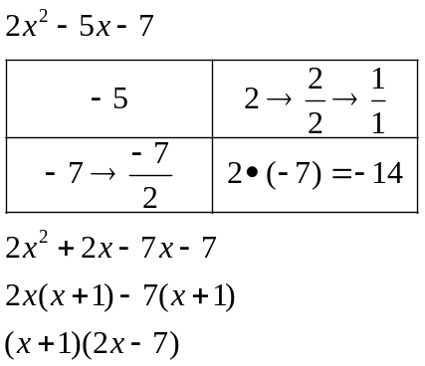

Example
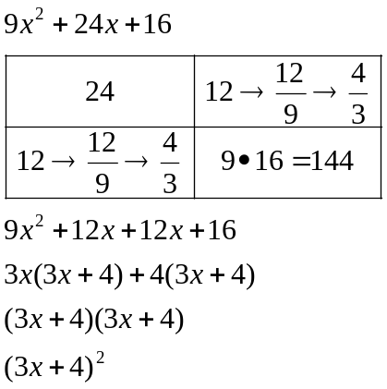

Example
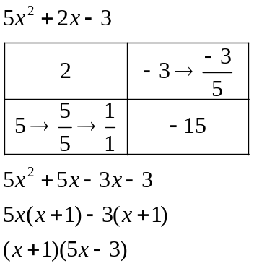

Example
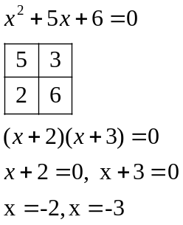

Example
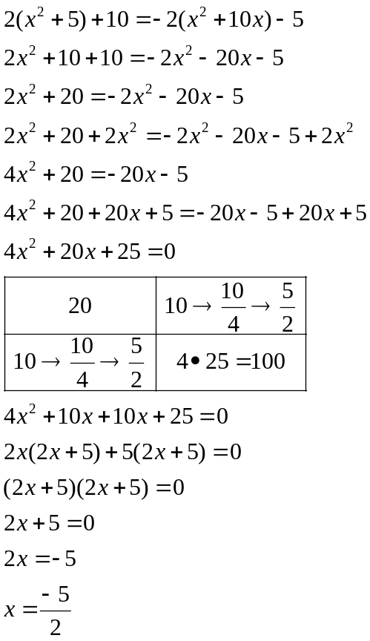

Example
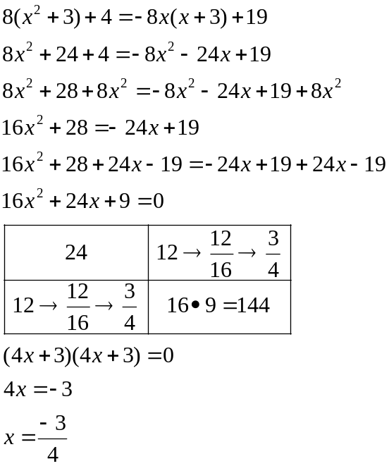

Example
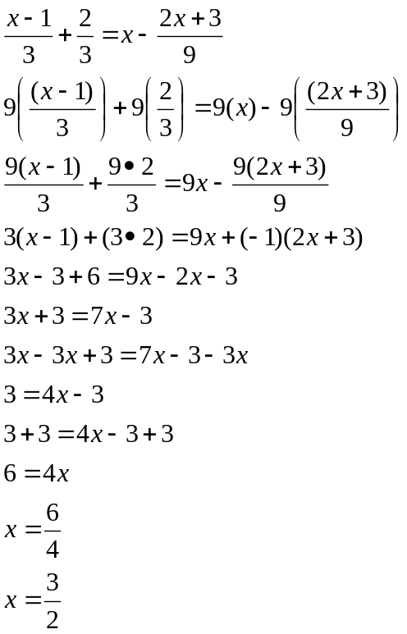

Example
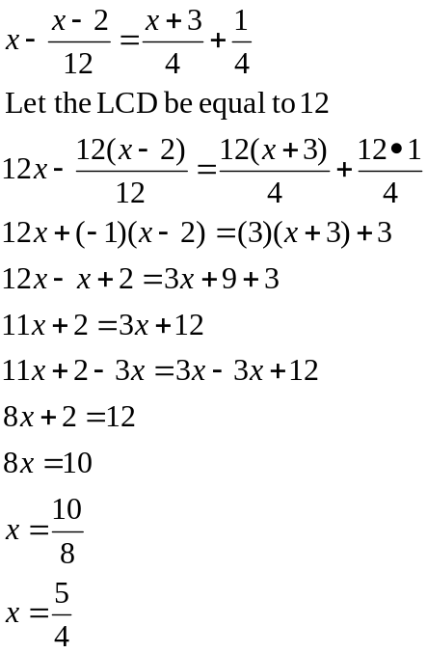

Example
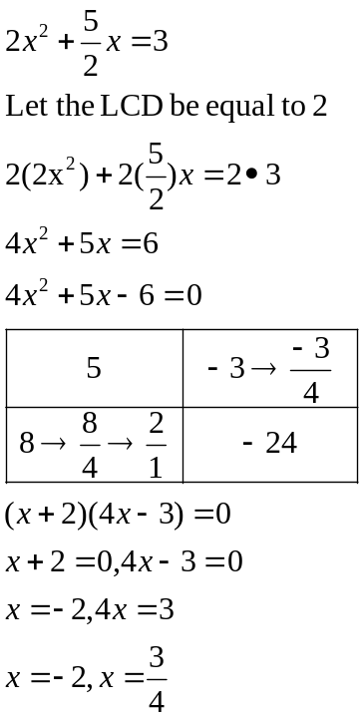

Example
